WESTERN REGIONAL PARTNERSHIP
Monthly Update

June 2024 Updates

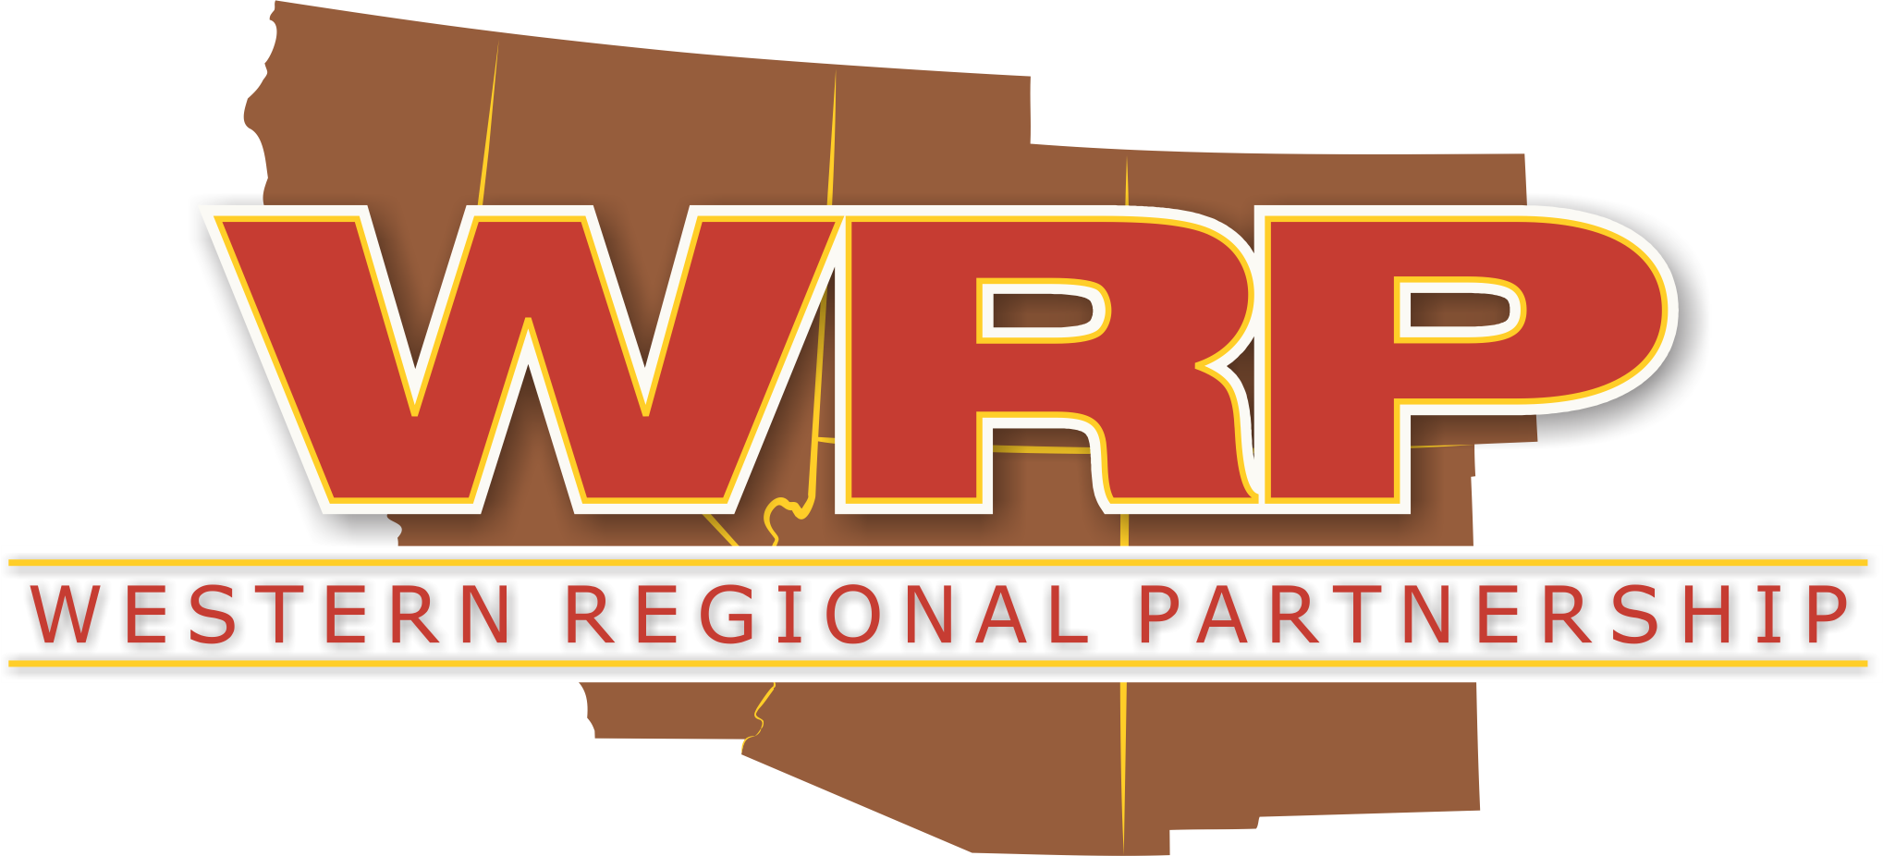
WRP sends out monthly updates on agency efforts relevant to the WRP Mission. This includes publicly available information from WRP Partners and agency news releases, etc. to assist in creating greater awareness of current WRP Partner actions. If you have any updates you would like to share, please email that information to amyduffy@westernregionalpartnership.org.

Featured Article on WRP
Contents
Featured Article on WRP 1
Tribal Engagement Committee (TEC) 1
Energy 2
Federal Updates 2
State Updates 2
Tribal Updates 2
Regional Updates 2
Natural Resources 3
Federal Updates 3
State Updates 4
Tribal Updates 5
Regional Updates 5
Military Readiness, Homeland Security, Disaster Preparedness and Aviation 6
Military Readiness 6
Homeland Security / Disaster Preparedness 7
Aviation 8
Spectrum 9
GIS 10
Miscellaneous 10

Featured Article on WRP 1
Tribal Engagement Committee (TEC) 1
Energy 2
Federal Updates 2
State Updates 3
Tribal Updates 3
Regional Updates 3
Natural Resources 3
Federal Updates 3
State Updates 4
Tribal Updates 6
Regional Updates 6
Military Readiness, Homeland Security, Disaster Preparedness and Aviation 7
Military Readiness 7
Homeland Security / Disaster Preparedness 8
Aviation 9
SpectRum 10
GIS 10
Miscellaneous 10

An article in the State Aviation Journal featured the WRP Principals' Meeting Aviation/Airspace Needs Plenary Session.

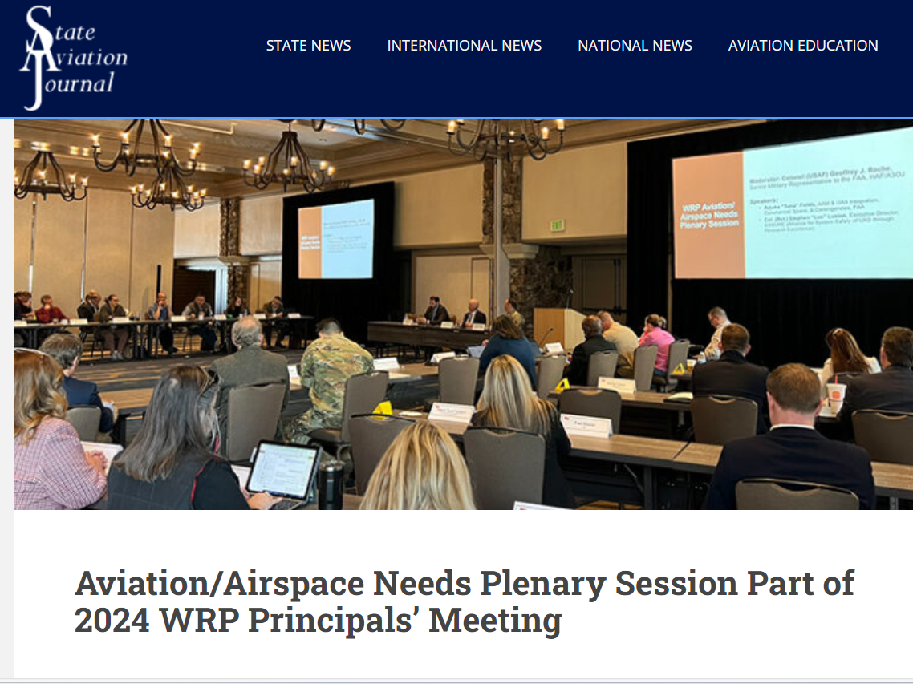

Tribal Engagement Committee (TEC)
The June 28th WRP TEC Meeting featured the following presentations:
- Overview of the DOE Office of Community Engagement and Opportunities for Collaboration
- Landslides and the National Landslide Hazard Reduction Program
The recording link: https://youtu.be/YfBbi_1iggc

Related resources:
- DOE OCE Virtual Office Hours - Biweekly, 2 PM EST – UPDATED Meeting Registration - Zoom
- USGS Grants: https://www.usgs.gov/programs/landslide-hazards/science/external-grants-overview

Energy

Federal Updates

BLM
- Nevada's 5 biggest solar projects, and the power line that will connect them
- Nevada transmission line sparks debate over costs of green energy
- $4.24B NV Energy transmission project takes step forward
- BLM advances Nevada power line touted as key to solar growth
- Acting Deputy Secretary Daniel-Davis highlights DOI's clean energy progress in Nevada
- 89 FR 50629 - Notice of Availability of the Proposed Resource Management Plan Amendments and Final Environmental Impact Statement for the Greenlink West Project in Clark, Esmeralda, Lyon, Mineral, Nye, Storey, and Washoe Counties, Nevada.

DOE
- DOE Announces $2.7 Billion to Boost Domestic Nuclear Fuel Supply Chain
- Over $41M in Funding to Deliver Clean Energy Solutions to Market
- $18 Million to Support Clean Energy Projects in 24 States and Local Governments
- $10.6M Planned to Advance Floating Offshore Wind
- $9.5 Million to Study the Social Dynamics of Large-Scale Solar Siting and Permitting
- West Coast Study Shows How Seabirds Can Safely Share the Air With Offshore Wind Structures
- DOE Leads Effort to Improve the Cybersecurity of Energy Supply Chains
- DOE Selects Sandia National Lab To Bring Enhanced Wind Turbine Technology to Market
- PNNL Scientists Are Working to Advance the Future of Floating Offshore Wind Farms
- New Funding for Improvements to the Distribution Power Grid
- New Report Breaks Down State-Level Renewable Energy Siting Policies and Permitting Authorities Across the Nation
- Sandia National Laboratories developed the Microgrid Design Toolkit, a decision-support software for microgrid designers that is publicly available for download.
- Funding Opportunities:
  - $1.3 Billion to Fund the Expanding National Electric Vehicle Charging Network. Attend the informational webinars to learn more, and apply by August 28.
  - EERE’s Geothermal Technologies Office announced a new funding opportunity of up to $7 million to assist the development of regional grid models. Send your letter of intent by July 24 and submit your application by September 9 to get involved.

FERC
- FERC Seeks Comment on Potential DLR Framework to Improve Grid Operations & Fact Sheet
- Acting Deputy Secretary Daniel-Davis highlights DOI's clean energy progress in Nevada

State Updates
- AZ: ACC power plant environmental ruling sparks opposition

Tribal Updates
- Navajo Summit Looks at History and Future of Tribe’s Relationship With Energy

Regional Updates
- Judge dismisses Native American challenge to $10B SunZia energy transmission project in Arizona
- Session Recordings From the Wind Energy & Wildlife Regional Training Now Available!
- Southern California Edison has signed power purchase agreements power purchase agreements with geothermal power company Fervo for power from its advanced geothermal project under construction in southwest Utah.

Natural Resources

Federal Updates
- Supreme Court Rio Grande ruling could ripple through other water cases
- U.S Supreme Court rejects Texas-New Mexico water deal
- SCOTUS rejects proposed resolution to Rio Grande water dispute
- America’s largest investment in federal public lands is coming
- DOI and USDA announced a proposed $2.8 billion through Great American Outdoors Act National Parks and Public Land Legacy Restoration Fund (GAOA LRF), including multiple grants in California.

EPA
- EPA Publishes its 2024-2027 Climate Adaptation Plan

DOI
- $2.8 Billion to Protect Public Lands, Support Conservation Efforts Across the United States
- $725 Million to Clean Up Legacy Pollution
- $700 Million for Long-Term Water Conservation in the Lower Colorado River Basin
- $142 Million to Bolster Resilience to Drought and Boost Water Supplies
- $127 Million to Clean Up Legacy Pollution Across Five States
- $87 Million for Wetland Conservation Projects and National Wildlife Refuges
- $43 Million for Rural Water Projects
- Four New National Recreation Trails Designated
- Public Lands Conservation, Investments in the Conservation Workforce Highlighted in New Mexico

DOI-BLM
- Endangered wildflower threatened by Nevada lithium mine

DOI-Bureau of Reclamation
- Bureau of Reclamation seeks public comment on environmental assessment of proposed water conservation agreement
- Reclamation and partners celebrate completion of critical water supply infrastructure for San Joaquin Valley
- $700 Million for Long-Term Water Conservation in the Lower Colorado River Basin
- $142 Million to Bolster Resilience to Drought and Boost Water Supplies
- $43 Million for Rural Water Projects
- Funding Opportunities:
  - The Cooperative Watershed Management Program which offers phase I funding to design projects, form watershed collaboratives, and conduct watershed planning for up to $300k over 3 years with no cost-share requirement. Proposals are due September 3rd, 2024
  - WaterSMART: Large-Scale Water Recycling Projects for Fiscal Years 2023 and 2024, Third Submittal Due September 30, 2024

DOI-NPS
- $15 million to make national parks more resilient to Climate Crisis

DOI-USFWS
- Rio Grande Chub and Sucker Not in Danger of Extinction
- $3.4 million in funding to prevent and combat the spread of aquatic invasive species in Lake Tahoe.
- Funding Opportunity: Funding Available for Tools and Projects that Eradicate Invasive Species

DOI-USGS
The US Geological Survey published its Annual Report on water levels and water quality in the Navajo aquifer in northeastern Arizona.

USDA
- $66 million for projects to reduce wildfire risk, protect water quality and improve forest health across the nation, including two grants to California.

USDA-NRCS
- $66M for Conservation Work with States, Tribes, Private Landowners
- Funding Opportunity: Funding Opportunity and Proposal Submission Process for the Wetland Reserve Enhancement Partnership for Fiscal Year 2024.

USDA-USFS
- USDA Forest Service seeks public comment on draft guidance for old growth management on national forests

State Updates
- Water Storage Grants Awarded to Western States

Arizona
- Governor Signs Bipartisan Water Legislation that Promotes Sound Water Management, Sustainable Growth
- Arizona Legislature talked a good game on water, then chose chaos

California
- Governor Newsom visits the nation’s largest river restoration project
- Sites Reservoir project clears hurdle thanks to streamlining law
- DWR has released a California Water Plan Update 2023 companion document that provides a planning guide to support watershed managers. The draft Watershed Resilience Framework and Toolkit — A Guide to Accelerate Resiliency in California’s Watersheds helps managers to better understand climate effects and vulnerabilities. Other supporting documents can be found on the Update 2023 webpage.
  - The California Water Plan Update 2023 Roadmap to Resilience, Objective 1 is: Support Watershed Resilience Planning and Implementation.
  - Objective 2 in the California Water Plan Update 2023 Roadmap to Resilience is: Improve Resilience of “Backbone” State, Federal, and Regional Built Water Infrastructure.
- The California Water Commission is looking for input on its public outreach and engagement efforts. The commission has set up an online survey to gather opinions and ideas from interested parties.
- New scientific strategy helps make case for holistic management of California rivers
- A study examining long-term trends of water supplies and uses in California has been published in the latest issue of San Francisco Estuary and Watershed Science.
- The California Extreme Precipitation Symposium is set for Thursday, July 11 at UC Davis
- The Flood-Managed Aquifer Recharge (Flood-MAR) will meet on Aug. 7, with a presentation on the recently released Merced River Watershed Flood-MAR Reconnaissance Study.
- The annual California Water Data Summit (Aug. 15 and 16, in San Diego) offers a forum for engaging with new ideas and approaches to water data. This year’s topics will include artificial intelligence, data systems for water management, and data for planning uncertainties.
- The Ocean Protection Council (OPC) has released a guidance document to help California communities prepare and adapt to rising sea levels. The State of California Sea Level Rise Guidance: 2024 Science and Policy Update finds that seas will likely rise by nearly a foot by 2050 and potentially as much as 12 feet by 2150.
- DWR's monthly water loss webinar. Register here
- A new report, The Magnitude of California’s Water Challenges, examines the climate, society, economy, and ecosystems problems unfolding in the state.
- Flood-managed aquifer recharge (Flood-MAR) and land use issues are featured in The High Water Mark newsletter
- The Public Policy Institute of California has released a report on the challenges facing the state’s freshwater ecosystems.
- California Council on Science and Technology (CCST) has released its annual report.
- Funding Opportunity: DWR’s Water Desalination Grant Program for $1 million in grants that are available for projects that desalinate naturally-occurring brackish and ocean water for potable water supply. See Water Desalination Grant Program. Due Sept. 18.

New Mexico
- The New Mexico Interstate Stream Commission’s planning team is hosting a series of water planning Open House Events across New Mexico to listen and learn from communities. These open houses will help establish a roadmap for the future of water planning in our state.
- New Mexico Debates What to Do With Oil and Gas Wastewater

UTAH
- Gov. Cox issues statement on EPA’s Good Neighbor rule
- Could the U.S. Military Help Save the Great Salt Lake?

Tribal Updates
- As new water deals are signed, tribes seek a place at the table
- Historic Water Rights Settlement Approved by Navajo Nation Council
- Agreements on Tribal Water Rights and Involvement in Colorado River Negotiations Announced
  - Memorandum Article
  - Proposed Settlement Article
- Tribal Nations Announce First Ocean and Coastal Protections in U.S.
- Funding Opportunity: Tribal Domestic Water Supply Projects FY2024: Phase 1 is due August 4

Regional Updates
- Groundwater Declines in the U.S. Southwest
- U.S. Drought Monitor struggles to pace climate change, study says
- Across the US the IIJA is boosting projects large and small
- Can the Greater Sage-Grouse Be Kept Off the Endangered Species List?
- This year’s annual conference for the Floodplain Management Association will be in Henderson, Nevada. Running Sept. 3–6, the theme of the conference is “Flood Risk — Know Your Odds.”
- New Report: Bridging the Gap: The Power of Investment in Water
- WMI Signs New Agreement with the Western Association of Fish and Wildlife Agencies to Work on Landscape Conservation in Western States
- Webinar on nature-inclusive designs for coastal infrastructure
- The Lincoln Institute of Land Policy shared a short documentary entitled “Agriculture & Water in the West: A Community Takes Charge.” Watch the Video; More Info
- New Report: Bridging the Gap: The Power of Investment in Water. This report examines two scenarios surrounding the economic impacts of federal investment in water over the next 10 and 20 years
- Interactive Map of PFAS Contamination Crisis
- Pandemic Funds for Water Infrastructure?
- The newest volume of the Engineering With Nature (EWN): An Atlas, spotlights projects harnessing the power of nature-based solutions.
- The Groundwater Accounting Platform is gaining popularity among water managers as a data-driven tool to help track water availability.

WestFAST
- WestFAST Newsletter: NASA Satellites Find Snow Didn’t Offset Southwest US Groundwater Loss; President’s Investing in America Agenda Delivers More Than $142 Million to Bolster Resilience to Drought and Boost Water Supplies; May 2024 was Earth’s Warmest May on Record; and more.

WRRC
- WRRC’s Navajo County Factsheet highlights key water topics in Navajo County, including the county's reliance on groundwater, the significance of surface water from the Little Colorado River, and efforts to address water quality issues and wildfire impacts
- WRRC Water Webinar: Post-2026 Colorado River Operational Guidelines: An Overview of the Lower Basin's Alternative. Wednesday, Jul 17 - 12:00 pm – 1:15 pm Arizona Time. Zoom Link
- WRRC – Sumer Wave – June 7, 2024, June 21, 2024

WSWC
- Western States Water Newsletter: Issue #2614

Military Readiness, Homeland Security, Disaster Preparedness and Aviation

Military Readiness

DOD
- DOD Serves as Key Interagency Partner in Whole-of-Government Response to Climate Change
- Chollet to Become Austin’s Chief of Staff
- How US military bases became proving grounds for clean energy technology
- PFAS contamination: EPA orders Air Force cleanup of groundwater
- US adversaries have ‘formidable’ electronic warfare tools, officials warn
- Legacy Resource Management Program
  - Story Map: U.S. Navy Making Endangered Species History
  - Story Map: A Success Story: The Stephens' Kangaroo Rat at Fallbrook
  - Story Map: Saving Species, Supporting the Mission
- Funding Opportunity: (NPLD) DOD Legacy Resource Management Program (Legacy Program) Award Applications Are Due Friday, July 19. Learn more and apply here.

REPI
- Webinar - July 24 at 1:00 PM ET -Join the 2024 Designation Cycle Sentinel Landscapes Spotlight webinar

USAF
- Future of Davis-Monthan revealed following retirement of A-10
- Air Force tests AI-designed, 3D-printed drones
- New Air Force wing in Arizona gets nod from state lawmakers

Army
- Army tests next-gen long-range fires capability in Pacific
- Delays push Army’s hypersonic missile to fiscal 2025
- Army placed $1.1B order for GE T700 Engines Worth More Than $1.1 Billion
- Robotic vehicles to fight with enemy forces in Army training event
- ADC Podcast: Insights from RAND on Natural Hazard Vulnerabilities

Navy
- The Navy just committed nearly a billion dollars to almost 50 companies for various drone-related work to help develop the service’s “Unmanned Surface Vehicle Family of Systems,” DOD announced

USMC
- The CH-53K Moves to Yuma: The Future is Now
- Endangered Pacific pocket mice reintroduced at Camp Pendleton
- New Marine center aims for immersive, realistic approach to wargaming

Space Force
- Space Force working with SpaceX to closely watch falling Starlinks
- Why the Space Force Wants to ‘Flip the Script’ On Space Domain Awareness

Homeland Security / Disaster Preparedness
- States beg insurers not to drop climate-threatened homes

FEMA
- FEMA to Host First-Ever Summit on Risk Communications, Crisis Communications and Community Engagement
- Should FEMA recognize extreme heat and wildfire smoke as ‘major disasters?
- FEMA Seeks Feedback on the Draft “Planning Considerations: Putting People First” Guide. The feedback period will conclude at the close of business on July 10. Info here.
- FEMA is promising to be more 'forward-leaning' this hurricane season
- Funding Opportunities:
  - $300M to Strengthen Community Resilience to Flooding: The application window opens on June 1, 2024, and the last eligible disaster declaration date is May 31, 2025. The funding opportunity is available on Grants.gov.
  - $10.8M Available for Fiscal Year 2024 Regional Catastrophic Preparedness Grants. The application period closes at 5 p.m. ET on July 25.
  - To provide funding for mitigation opportunities immediately after a flood disaster event with the aim of delivering mitigation outcomes. Due: January 15, 2025. Learn more

Cyber
- DHS highlights AI as a threat and asset to critical infrastructure in new priority guidance
- Feds saw more cyberattacks but better detection last year, FISMA report says

Wildfire
- Administration Outlines Strategic Priorities to Strengthen the Nation’s Response to Wildfire
- $11 million to advance wildland fire research
- USDA Forest Service Seeks Public Comment on Draft Guidance for Old Growth Management on National Forests
- Old-growth forest plan offers protections, but no ban on cutting
- How to protect mature and old growth forests
- Extreme Wildfires Doubled Over Past Two Decades
- Wildfires rage across three states as evacuations, searches continue
- Mind the Gap’—reforestation needs vs. reforestation capacity in the western United States
- Administration Outlines Strategic Priorities to Strengthen the Nation’s Response to Wildfire
- Episode 33: U.S. Forest Service Program Invests in Wood Innovation by The AFRC Podcast: Sustainable Forests. Healthy Communities
CALIFORNIA
- California wildfires have already burned 90,000 acres, and summer is just beginning
- Cal Fire warns of possible 'rough' wildfire season
- Northern California wildfire remains largest in state at 19,000 acres
- California's Record Wildfires Spurred by Millions of Hidden Dead Trees
- California heat dome will send temperatures into the triple-digits across the West as fires burn
NEVADA
- Wildfires, cheatgrass have Nevada feeling the need for seed
NEW MEXICO
- Recovery Efforts in New Mexico as it Responds to Recent Wildfires in the Area
- New Mexico Ruidoso residents face South Fork and Salt fires: 2 dead, floods swap area
- New Mexico wildfires: Firefighters face burn scar flood threat
- Wildfire season and the evolution of forest management in New Mexico

Aviation
- Aviation/Airspace Needs Plenary Session Part of 2024 WRP Principals’ Meeting
- NBAA Questions FAA’s Plan for New Rules on Flights Critical to Communities
- GE working on hybrid engines to cut aviation emissions
- Colorado airport plans phased runway widening in 2026
- Utah Launches Groundbreaking Air Transportation System
- Utah initiative calls for creating air taxi system by 2034
- Strong opposition to potential ‘onerous’ airstrip closures in Utah
- Utah Establishes Air Mobility Framework
- March 2024 U.S. Airline Traffic Data Up 6.3% from the Same Month Last Year
- Prospect of air taxis prompts US cities to take action
- NASAO and FAA Sign MOU to Enhance Partnership on the State Block Grant Program
FAA
- $123 Million in Grants to Improve Airports
- Striving for Zero Serious Close Calls on the Nation’s Runways During One of the Busiest Summers in Years
- FAA and EASA Pledge Strong Cooperation to Address Aviation Challenges of the Next Decade
- The FAA can now track the vehicles of three additional space companies in near-real time during their launch and reentry operations for safety and airspace efficiency. Virgin Galactic, Sierra Space and Firefly will transmit vehicle telemetry data - such as position, altitude, and speed – to the FAA via the Space Data Integrator (SDI) tool. SDI data increases situational awareness, helps to reduce airspace closures, and contributes to safety for all airspace users.
- FAA to Receive Launch and Reentry Flight Data from Two More Companies
- One-Stop Shop for FAA Commercial Space Documents: Effective June 30 all of the regulatory based documents of the FAA Office of Commercial Space Transportation will be available in an online one-stop shop.
- The FAA welcomes public comment on a draft environmental assessment (EA) as part of the commercial space transportation license application review process for the Inversion Space reentry vehicle known as Ray. The draft EA evaluates the potential environmental impacts associated with the reentry, splashdown and recovery operations of the Ray reentry capsule in the Pacific Ocean off California. Comments must be submitted by July 5.
- Congress extended the commercial human spaceflight learning period until Jan. 1, 2025. This means the FAA remains prohibited from issuing regulations for occupant safety. The FAA is managing a rulemaking committee examining possible future regulations and is working with stakeholders to develop voluntary consensus standards. In addition, the agency updated its recommended practices. Learn more about the FAA oversight of commercial human spaceflight.
- FAA plans new safety measures for public charter flights
- FAA Statement on eVTOL Aircraft Certification
- A ‘roller coaster’: Inside the FAA’s quest for stable funding
- Airport Infrastructure Grants Awarded to WRP States
- Nearly $187 Million in Grants to Modernize Airports
DRONES
- US Central Command to demo integrated counter drone sensors this fall
- The crime-fighting drone that beats police to the scene
- FAA OKs Joby Aviation's ElevateOS for air taxi network
- Signature Signs MOU on Chainwide eVTOL Charging
- Counter UAS Market Report 2024 - 2029
- Drones: Actions Needed to Better Support Remote Identification in the National Airspace GAO-24-106158, June 6
- Amazon gets FAA approval allowing it to expand drone deliveries for online orders

SPECTRUM
- Next Steps for Innovative Spectrum Sharing
- NTIA, FCC, Navy Work to Expand Innovative 3.5 GHz Spectrum Sharing Framework
- FCC, NTIA move to expand spectrum access for commercial wireless in partnership with Navy
- New NTIA Data Show 13 Million More Internet Users in the U.S. in 2023 than 2021
- Pentagon to issue guidance on open radio access networks to support 5G
- What might be 6G's spectrum needs?
- Tribal Broadband: Additional Assistance to Recipients Would Better Support Implementation of $3 Billion in Federal Grants GAO-24-106541, June 24
- Funding Opportunity: USDA Rural Development Broadband Technical Assistance Program – FY2024. Applications are due by August 20, 2024. Notice of Funding Opportunity: 2024-13691.pdf - Broadband Technical Assistance | Rural Development

GIS
- A new online video shows how it is easier than ever to access data from the National Resource Conservation Service (NRCS).
- New updates to the California Protected Areas Database and California Conservation Easement Database are now available for download.

Miscellaneous

Federal

DOI
- $621.2 Million in Payments to Support Vital Services in Communities
- This Week at the Interior - June 28, 2024
- This Week at the Interior - June 21, 2024
- This Week at the Interior - June 14, 2024
- This Week at the Interior - June 7, 2024

Infrastructure
- $1.8 Billion in Infrastructure Grants Across the Country, Putting More Projects into the Pipeline as Part of Our Infrastructure Decade
- USDOT Announces $1.8 Billion in RAISE Grants
- Applications for $1.3 Billion in Funding to Continue Expanding National Electric Vehicle Charging Network
- $185 Million in Allocations for Rehabilitation of High Hazard Potential Dams
- $108 Million to Improve Infrastructure and Road Safety on Federal and Tribal Lands
- US electricity demand from EVs jumps to new highs in early 2024
- UDOT to “Connect the West” with major federal grant
- Arizona approves $8.2B for statewide transportation work until 2029
- NDOT-led Study Receives Award for Efforts to Reduce Animal-Vehicle Collisions and Keep Wildlife Connected
- Utah DOT Gets $1.4B for New State Transportation Projects
- Funding Opportunity: For projects that seek to achieve a reduction in the number of wildlife-vehicle collisions; and improve habitat connectivity for terrestrial and aquatic species. Due September 4, 2024

State Updates
CALIFORNIA
- Governor Newsom delivers 2024 State of the State address
- Governor Newsom announces historic land return effort on the 5th anniversary of California’s apology to Native Americans
- 1 in 6 new trucks, buses, and vans in California are zero-emission

NEW MEXICO
- Governor elected to lead Western Governors’ Association - As new WGA Chair, Lujan Grisham will prioritize housing
UTAH
- Energy and public lands issues taken up in the special session

Regional Updates
WGA
- Western Governors elect New Mexico Governor Lujan Grisham as Chair of the Western Governors’ Association
- Highlights from the WGA 2024 Annual Meeting
- WGA's Chair Wyoming Governor Mark Gordon released the Decarbonizing the West initiative report
- WGA signs shared stewardship MOU with USDA
- At the WGA’s 2024 Annual Meeting, Western Governors formally approved five policy resolutions. The resolutions represent the Governors’ collective policy on disaster preparedness and response, transportation infrastructure, water resource management, cleaning up abandoned hard rock mines, and water quality.
  - WGA Policy Resolution 2024-05, Disaster Preparedness and Response
  - WGA Policy Resolution 2024-06, Transportation Infrastructure in the Western United States
  - WGA Policy Resolution 2024-07, Water Resource Management in the West
  - WGA Policy Resolution 2024-08, Cleaning Up Abandoned Hardrock Mines in the West
  - WGA Policy Resolution 2024-09, Water Quality in the West

